Environmental Issues

By:

Max

Did you know that things humans do can affect the environment? Many people are affecting the environment in many ways. I got this information from a book called ecology for kids, a student’s science book, and an article on zoos by McClatchy Foreign Staff. People are using too many natural resources, they pollute, and there are too many humans.

Natural resources are becoming a problem. People use too many of them. Natural resources are things that come from nature. They are not manmade. Manmade items are made from natural resources. For example, fish come from the ocean. Overfishing can endanger predators. Iron comes from the ocean as well. Also, when you chop down trees to get wood, that can effect ecosystems for animals; such as the wilderness and ocean. Some natural resources cannot be replaced. When you mine coal, it is gone forever. Although this affects the environment, it helps humans survive. Humans should stop using TOO many natural resources. People do help animals survive in zoos, though.

Pollution is affecting the environment in many ways, too. People are polluting the ocean by pouring garbage into it. They also pollute the air by releasing chemicals. With all this polluting, species are becoming endangered, and humans can’t enjoy the nature in the woods. People should pollute less by making more electric cars, recycling more, use the electricity that you need, and not wasting water.

Lastly, the human population is affecting and outnumbering the wildlife. There are too many humans. Their structures take the animals’ space, and affect their habitat. Humans also eat too much meat. That is why mammoths are extinct. Humans should stop building too many structures, have less babies, and eat less meat.

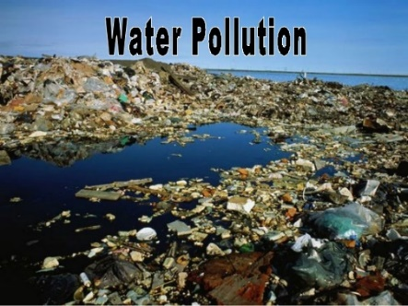 So if you want to enjoy nature, then we; humans should stop polluting so that we can walk into the woods and enjoy the nature. Humans should use less natural resources, make less pollution, and manage the human population. So stop polluting so much and go and enjoy nature! (go to <http://www.madmaxhacks.com/hnf5.html>)

(I found this picture at <http://image.slidesharecdn.com/powerpointonenvironmentalissues-130422215919-phpapp02/95/powerpoint-on-environmental-issues-4-638.jpg?cb=1366668045>)